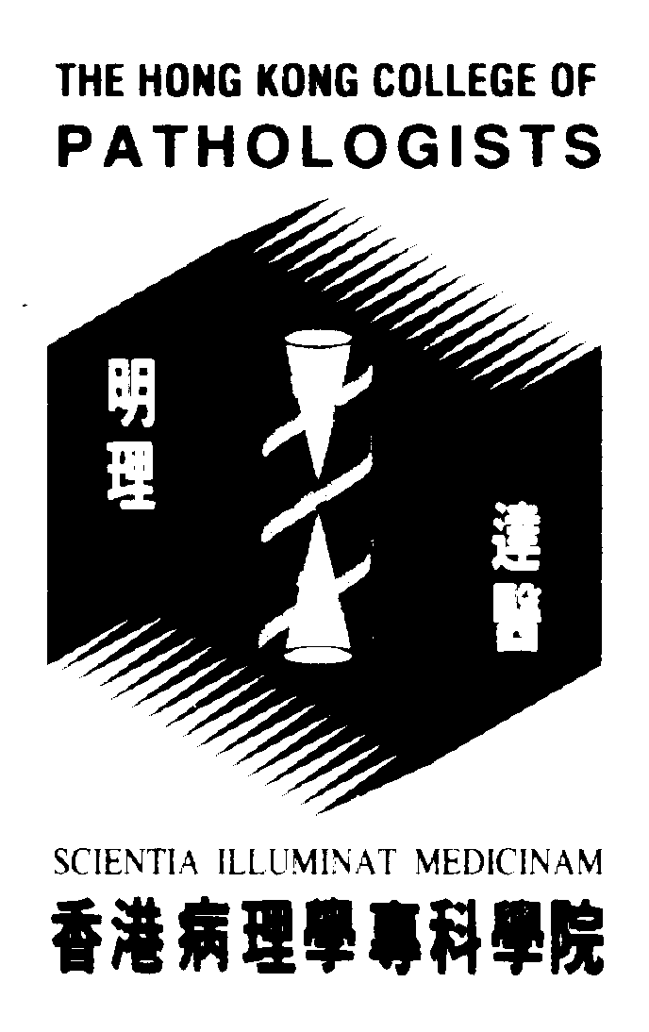
Internal use
HKCPath Ref.:
HKAM Ref.:
Fellows of Hong Kong College of Pathologists
CME/ CPD Program Attendance Record for
Chairing/Presenting at Formal College Approved Activity (AP)

Program Name:
Date / Time:
Venue: |  | Duration in Hours:
Organizer:
Organizer: | Contact Person:  Tel: Fax: Email:
CME points Accredited | Speaker: 1 CME/CPD point for 10 min presentation  Chairman: 2 CME/CPD points for chairing each 1-hour session  Max. 6 CME points for an 1-hour activity regardless of the roles taken in that activity

Invited Speaker
 | Full Name  (in block letters) | Duration of Presentation in minutes
1
2
3
4
5
Chairman
 | Full Name  (in block letters) | Duration in minutes
1
2
3
4
(Note: No CME/CPD points for Participation as an Attendee [PP] will be awarded for the part of FCAA where CME/CPD points for AP have been awarded.)

Please return this attendance sheet within 2 weeks after the event to:
The Hong Kong College of Pathologists
Room 606, HKAM Jockey Club Building
99 Wong Chuk Hang Road, Aberdeen, Hong Kong
Tel: 2871 8756 Fax: 2871 8755
Email: hkcpath@hkcpath.org

