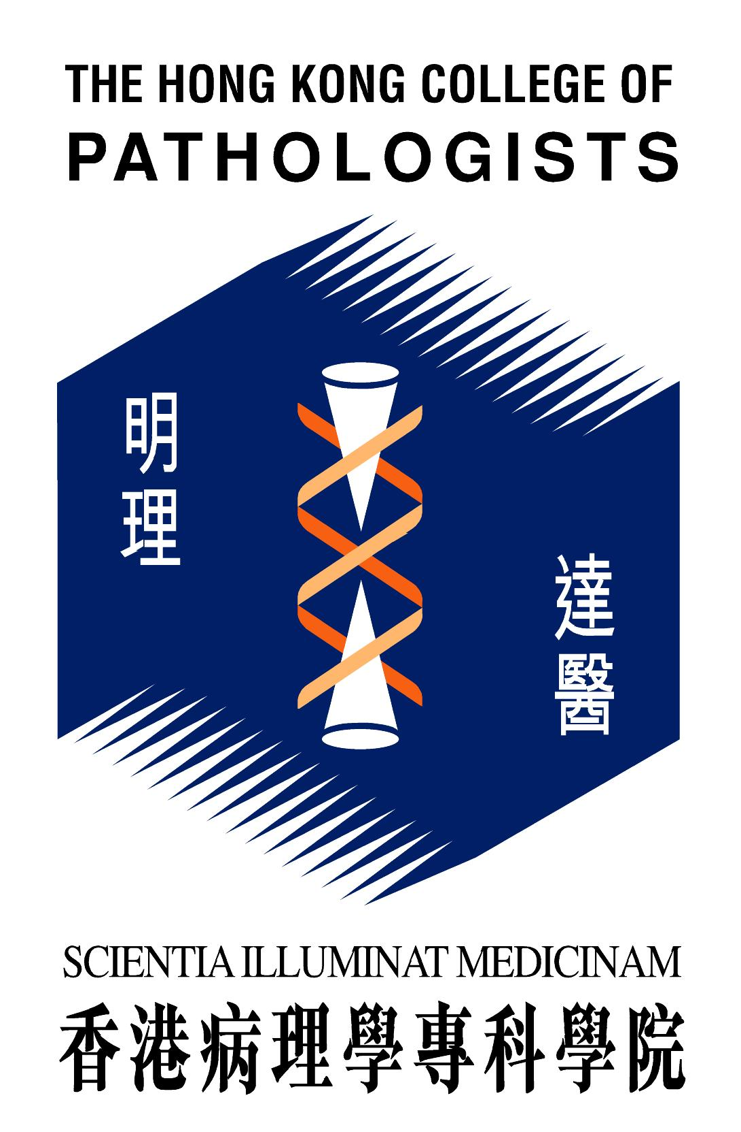

CHAN WOON CHEUNG EDUCATION AND RESEARCH FUND

In 1991, friends, colleagues and former students of the late Dr. Chan Woon Cheung endowed a fund in his memory to promote education, training and research in Pathology.

Regulations Governing the Fund

- The fund shall be named “The Chan Woon Cheung Education and Research Fund”.
- The fund shall only be applied towards the promotion of education, training and research in Pathology, such as,
i. Research grants for studies in Pathology, or
ii. Grants to support training in Pathology, including passage fees and subsistence, where the training is conducted in Hong Kong or the applicant is currently working in Hong Kong.
- Local and overseas workers in Pathology, both members and non-members of The Hong Kong College of Pathologists, may apply for grants for the purposes set out in b. above.
- Applications for support from the fund may be made on the form prescribed by the Council of The Hong Kong College of Pathologists, and shall be subject to academic scrutiny by the Council. The decision of the Council shall be final.

Administrative Arrangements

- The whole of the sum subscribed shall form the endowment fund and shall be invested at the discretion of the Council.
- Only the income shall be available for the payment of grants except under special circumstances as decided by the Council.
- Deadline for application submission is the 31st of May of each year. The results will be announced to the applicants no later than the end of August of the same year.
- After providing for awards in any one year, or if no award is made, any sum remaining may be carried forward to meet the costs of awards in subsequent years, or may be added to the capital sum for investment.
- The Council may establish a committee to undertake preliminary assessment of the applications for advice to the Council.
- Principal grant holders receiving support from the fund will be required to submit a report to the Council at the end of the period of education, training or research.
- At the beginning of each financial year, the Hon. Treasurer shall supply to the Council an annual statement of account for the fund indicating the income available for allocation during the year in question.

Requirements for the Applicants and Awardees of Chan Woon Cheung Education and Research Fund

- An applicant is required to complete an application form for the Fund, to be submitted together with a curriculum vitae.
- An applicant is required to provide a detailed protocol for any research project (applicable to research project only).
- Applicant is required to submit the ethics approval letter from local institution (applicable to research project only).
- If other sponsorship(s) is/are awarded for the same purpose, the distribution of each fund must be submitted.
- An awardee must comply with the requirements of the College on the Fund award and acknowledge the fund sponsorship in the research reports.
- The award is subject to audit. An awardee is required to provide expenditure summary and receipts (if any) at the end of the project / training.
- Surplus, if any, needs to be returned to the College.
- An awardee is required to present in the Trainee Presentation Session at the nearest AGM after completion of the research project or within 3 years after approval of the Fund, whichever is earlier (applicable to research project only).
- An awardee is required to submit a written report for publication in the College newsletter after completion of the research project or within 3 years after approval of the Fund, whichever is earlier (applicable to research project only).

Completed application form should be returned to the Registrar of The Hong Kong College of Pathologists (Address: Room 606, 6/F, HKAM Jockey Club Building, 99 Wong Chuk Hang Road, Aberdeen, Hong Kong).
Application Form
The Chan Woon Cheung Education and Research Fund
PART I

Name of applicant: ______________________________________________________
Qualification(s): _________________________________________________________
Institute and unit: ________________________________________________________
Appointment(s) held: _____________________________________________________
Address: _______________________________________________________________
_______________________________________________________________________
Tel.: _________________ Fax: _________________ E-mail:______________________
Are you a member of The Hong Kong College of Pathologists: Yes/No (delete as appropriate)
If yes, category of Membership: _____________________________________________
Brief summary of proposed research/training (details to be attached):
_______________________________________________________________________
_______________________________________________________________________
_______________________________________________________________________
Amount of grant requested (with detailed breakdown):
_______________________________________________________________________
_______________________________________________________________________
_______________________________________________________________________
Have you applied for other sponsorship? ______________________________________
If yes, please give details: __________________________________________________
_______________________________________________________________________
_______________________________________________________________________
_______________________________________________________________________
I understand that if a grant is approved, I shall submit a report to the Council at the end of the research/training.

Signature: __________________________ Date: ____________________________
[Note: Please also submit your curriculum vitae, and complete Part II if the application is for research.]
Ref. No. (for official use)
Application Form
The Chan Woon Cheung Education & Research Fund
Part II (applicable to research only)
==============================================================

- SUBMISSION: New Project Re-Submission
- AMOUNT OF GRANT APPLIED FOR: HK$_______________________________
- TITLE OF PROJECT (Limit to 25 words)
- ABSTRACT OF PROJECT (Limit to 250 words, follow BMJ format)
- POTENTIAL APPLICATION: Please explain the potential benefits to pathology and healthcare system. (Limit to 50 words)
- PROPOSED START AND END DATES (dd/mm/yyyy).

6a. Start Date: (dd/mm/yyyy) |  | 6b. End Date: |  | 6c. Grant Period: |  | Months

- SUMMARY OF FINANCIAL SUPPORT REQUESTED (To the Nearest HK$)
(dd/mm/yy) | 01/04/ - 31/03/ | 01/04/ - 31/03/ | 01/04/ - 31/03/ | Total (HK$)
Staff
Other Expenses
Equipment
Sub-total
Grand Total

- ETHICS APPROVAL: Written documentation of ethics approval, or of application for such approval, must be submitted with the application form.

8a. Date Received (dd/mm/yyyy) |  | 8b. Reference No.:

- APPLICANT & CO-INVESTIGATORS (PROJECT TEAM)
Please list the names, titles, appointments, working addresses of the applicant and all co-investigators in a separate sheet.

10. DETAILS OF FINANCIAL SUPPORT REQUESTED

11. OTHER SUPPORT

(a) Have any of the applicants listed above submitted this or a similar YES NO
research proposal to any other funding agency (local or overseas)
in the past 3 years?
If yes, provide details:-

(b) Is this or a similar research proposal currently submitted or intended YES NO
to be submitted to any other funding agency (local or overseas) by any of the
applicants listed above in the next 6 months?
If yes, provide details:-

If the answer to any of the above is “YES”, the applicant is requested to notify the Registrar of The Hong Kong College of Pathologists once funding result is available.

12. PROPOSED RESEARCH PROJECT
(a) Title
(b) Introduction (Limit to 600 words)
(c) Aims
- Plan of investigation (Data/statistical analysis)
(e) Timetable of work
(f) Existing facilities
(g) Justification of requirements
(h) Purpose and potential for implementation of results
(i) Key references
- List of additional material
- Research ethics / safety approval

- CURRICULA VITAE OF APPLICANT AND CO-INVESTIGATORS
Please limit each CV to only one page with the applicant’s CV on the first page.

14. DECLARATION AND AUTHORISATION

Applicant & Co-investigators

I / We certify that the statements herein are true, and accurate to the best of my knowledge. I am aware that any false, fictitious, or fraudulent statements or claims may subject me to criminal, civil, or administrative penalties. I agree to accept responsibility for the scientific conduct of the project, to abide by the rules and regulations of Chan Woon Cheung Education & Research Fund and to provide the required report if a grant is awarded as a result of this application.

I /We authorize The Hong Kong College of Pathologists to handle the personal data / information provided in this application form in accordance with the Privacy Ordinance of Hong Kong.

Signature |  |  | Name (Capitals) |  | Date
1.
2.
3.
4.

Administering Institution

This application should be acknowledged by the Head of the Department where the applicant is currently working with.

I certify that the statements herein are true, complete and accurate to the best of my knowledge, and accept the obligation to comply with the rules and regulations of Chan Woon Cheung Education & Research Fund if a grant is awarded as a result of this application.

Signature of HEAD OF DEPARTMENT
NAME (BLOCK) |  |  |  | DATE
INSTITUTION/DEPARTMENT

