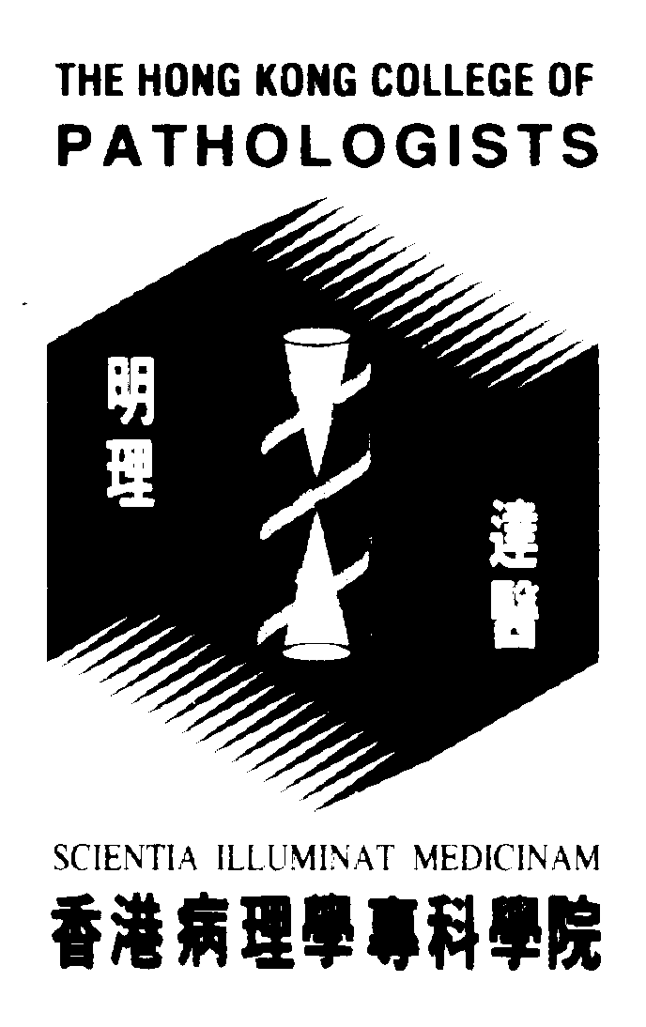
Internal use
HKCPath Ref.:
HKAM Ref.:
Fellows of Hong Kong College of Pathologists
CME/ CPD Program Attendance Record for
Chairing/Presenting at FCAA (AP)

Program Name:
Date / Time:
Venue: |  | Duration in Hours:
Organizer:
Organizer: | Contact Person:  Tel: Fax: Email:
CME points Accredited | Speaker: 1 CME/CPD point / 10 mins. (Max. CME points ______ if any)  Chairman: 2 CME/CPD points / 1 hour session
Invited Speaker
 | Name  (in block letters) | Duration of Presentation in minutes
1
2
3
4
5
Chairman
 | Name  (in block letters) | Duration in minutes
1
2
3
4
5
(Note: A maximum of 6 CME/CPD points may be accredited for AP of a 1-hour activity regardless of the roles taken in that activity. No CME/CPD points for Participation as an Attendee [PP] will be awarded for the part of FCAA where CME/CPD points for AP have been awarded. Undergraduate and post-graduate teaching may not be accepted as a form of CME/CPD)
Please return to:

Signature / Official Chop of Organiser
The College Secretary
The Hong Kong College of Pathologists
Room 606, HKAM Jockey Club Building
99 Wong Chuk Hang Road, Aberdeen, Hong Kong
Tel: 2871 8756 Fax: 2871 8755

